Section 3.2 — Maternal Age by Birth Order

Figure 2: Maternal Age by Birth Order
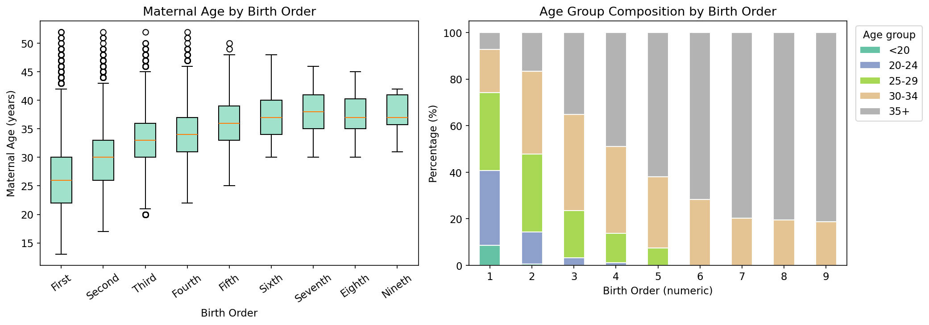

Table 1: Maternal Age Descriptive Statistics by Birth Order
Birth Order | Parity | N | Mean | Median | Std Dev | Min | Max | Q1 | Q3
First | 1 | 128,521 | 26.27 | 26.00 | 5.31 | 13 | 52 | 22.00 | 30.00
Second | 2 | 110,651 | 29.83 | 30.00 | 4.80 | 17 | 52 | 26.00 | 33.00
Third | 3 | 49,063 | 32.76 | 33.00 | 4.48 | 20 | 52 | 30.00 | 36.00
Fourth | 4 | 10,845 | 34.32 | 34.00 | 4.35 | 22 | 52 | 31.00 | 37.00
Fifth | 5 | 2,505 | 35.80 | 36.00 | 4.33 | 25 | 50 | 33.00 | 39.00
Sixth | 6 | 503 | 37.29 | 37.00 | 3.98 | 30 | 48 | 34.00 | 40.00
Seventh | 7 | 138 | 38.01 | 38.00 | 3.96 | 30 | 46 | 35.00 | 41.00
Eighth | 8 | 36 | 37.53 | 37.00 | 3.97 | 30 | 45 | 35.00 | 40.25
Nineth | 9 | 16 | 37.56 | 37.00 | 3.37 | 31 | 42 | 35.75 | 41.00

Note: N = number of births. Q1/Q3 = 25th/75th percentile of maternal age.

Table 2: Age Group Composition (%) by Birth Order
Birth Order | <20 | 20-24 | 25-29 | 30-34 | 35+
First | 8.72 | 31.98 | 33.42 | 18.57 | 7.31
Second | 0.67 | 13.65 | 33.41 | 35.71 | 16.55
Third | 0.00 | 3.31 | 20.26 | 41.20 | 35.23
Fourth | 0.00 | 1.17 | 12.68 | 37.17 | 48.98
Fifth | 0.00 | 0.00 | 7.43 | 30.70 | 61.88
Sixth | 0.00 | 0.00 | 0.00 | 28.23 | 71.77
Seventh | 0.00 | 0.00 | 0.00 | 20.29 | 79.71
Eighth | 0.00 | 0.00 | 0.00 | 19.44 | 80.56
Nineth | 0.00 | 0.00 | 0.00 | 18.75 | 81.25

Note: Values represent the percentage of mothers in each age group within each birth order category.

5.2 Ordinal Logistic Regression (Proportional Odds Model)
The Ordinal Logistic Regression model (also known as the Proportional Odds Model) was fitted using maximum likelihood estimation with the BFGS optimization algorithm. This model is appropriate for ordinal dependent variables and assumes that the relationship between each pair of outcome categories is proportional.

Code Implementation
# Fit Ordinal Logistic Regression
ord_model = OrderedModel(y_ord, X_encoded, distr='logit')
ord_result = ord_model.fit(method='bfgs', disp=False)
# Export results
ord_result.summary()

Console Output
Fitting Ordinal Logistic Regression...
(May take 1-2 minutes for large datasets)
Model fitted successfully.
Saved: ordinal_regression_results.txt
Saved: ordinal_coefficients.csv
Saved: model_fit_stats.csv

Model Fit Statistics
Metric | Value
Log-Likelihood | -321209.1635
AIC | 642482.3270
BIC | 642822.1383
Pseudo-R-squared | 0.1142
Number of Observations | 302278
Converged | True
✓ Model converged successfully

Regression Coefficients
Variable | Coefficient | Std. Error | z-value | P>|z| | Signif.
age_group_20-24 | 1.8086 | 0.0392 | 46.0845 | 0.0000 | ***
age_group_25-29 | 2.9044 | 0.0388 | 74.9304 | 0.0000 | ***
age_group_30-34 | 3.8689 | 0.0389 | 99.5199 | 0.0000 | ***
age_group_35+ | 4.6644 | 0.0394 | 118.4465 | 0.0000 | ***
marital_status_Unmarried | -0.0202 | 0.0337 | -0.6005 | 0.5482
race_mother_Burgher | -0.5187 | 0.7667 | -0.6765 | 0.4987
race_mother_Indian Moor | 0.5476 | 0.8244 | 0.6642 | 0.5065
race_mother_Indian Tamil | -0.1808 | 0.7571 | -0.2387 | 0.8113
race_mother_Malay | 0.2834 | 0.7624 | 0.3717 | 0.7101
race_mother_Other Foreigners | -1.0337 | 0.7691 | -1.3441 | 0.1789
race_mother_Other Srilankans | -0.3402 | 0.7761 | -0.4384 | 0.6611
race_mother_Pakistan Moor | -0.9088 | 0.8426 | -1.0786 | 0.2808
race_mother_Sinhalese | -0.5535 | 0.7570 | -0.7312 | 0.4646
race_mother_Srilankan Chetty | -0.2545 | 0.9847 | -0.2584 | 0.7961
race_mother_Srilankan Moor | 0.2923 | 0.7570 | 0.3861 | 0.6994
race_mother_Srilankan Tamil | -0.3759 | 0.7571 | -0.4965 | 0.6195
Gender _Male | -0.0224 | 0.0072 | -3.1294 | 0.0018 | **
Hospital or Not_Not In Hospital | -0.2923 | 0.0493 | -5.9349 | 0.0000 | ***
province_mother_Eastern | 0.0108 | 0.0161 | 0.6673 | 0.5046
province_mother_North Central | 0.2278 | 0.0150 | 15.1792 | 0.0000 | ***
province_mother_North Western | 0.2138 | 0.0190 | 11.2336 | 0.0000 | ***
province_mother_Northern | 0.0383 | 0.0229 | 1.6719 | 0.0945
province_mother_Sabaragamuwa | -0.0538 | 0.0136 | -3.9499 | 0.0001 | ***
province_mother_Southern | 0.0283 | 0.0126 | 2.2501 | 0.0244 | *
province_mother_Uva | 0.0566 | 0.0148 | 3.8336 | 0.0001 | ***
province_mother_Western | -0.1643 | 0.0110 | -14.9695 | 0.0000 | ***
Birth_Weight(grams) | 0.0002 | 0.0000 | 24.0465 | 0.0000 | ***
1/2 | 2.8947 | 0.7582 | 3.8180 | 0.0001 | ***
2/3 | 0.6891 | 0.0027 | 253.3190 | 0.0000 | ***
3/4 | 0.6249 | 0.0045 | 140.0037 | 0.0000 | ***
4/5 | 0.4520 | 0.0102 | 44.4624 | 0.0000 | ***
5/6 | 0.4415 | 0.0218 | 20.2740 | 0.0000 | ***
Significance codes: *** p<0.001, ** p<0.01, * p<0.05, (blank) p≥0.05

Threshold Parameters (Cutpoints)
Cutpoint | Coefficient | Std. Error
1/2 | 2.8947 | 0.7582
2/3 | 0.6891 | 0.0027
3/4 | 0.6249 | 0.0045
4/5 | 0.4520 | 0.0102
5/6 | 0.4415 | 0.0218
Note: 5 cutpoint(s) estimated for 6 ordinal categories.

Model Equation
logit(P(Y≤j)) = β₀ⱼ + + 1.8086×age_group_20-24 + 2.9044×age_group_25-29 + 3.8689×age_group_30-34 + 4.6644×age_group_35+ - 0.0202×marital_status_Unmarried - 0.5187×race_mother_Burgher + 0.5476×race_mother_Indian Moor - 0.1808×race_mother_Indian Tamil + 0.2834×race_mother_Malay - 1.0337×race_mother_Other Foreigners - 0.3402×race_mother_Other Srilankans - 0.9088×race_mother_Pakistan Moor - 0.5535×race_mother_Sinhalese - 0.2545×race_mother_Srilankan Chetty + 0.2923×race_mother_Srilankan Moor - 0.3759×race_mother_Srilankan Tamil - 0.0224×Gender _Male - 0.2923×Hospital or Not_Not In Hospital + 0.0108×province_mother_Eastern + 0.2278×province_mother_North Central + 0.2138×province_mother_North Western + 0.0383×province_mother_Northern - 0.0538×province_mother_Sabaragamuwa + 0.0283×province_mother_Southern + 0.0566×province_mother_Uva - 0.1643×province_mother_Western + 0.0002×Birth_Weight(grams)

Interpretation Summary
Total predictors in model: 27
Statistically significant predictors (p < 0.05): 13
Positive associations (higher values → higher outcome):
• age_group_20-24 (coef = 1.8086, p = 0.0000)
• age_group_25-29 (coef = 2.9044, p = 0.0000)
• age_group_30-34 (coef = 3.8689, p = 0.0000)
• age_group_35+ (coef = 4.6644, p = 0.0000)
• province_mother_North Central (coef = 0.2278, p = 0.0000)
• province_mother_North Western (coef = 0.2138, p = 0.0000)
• province_mother_Southern (coef = 0.0283, p = 0.0244)
• province_mother_Uva (coef = 0.0566, p = 0.0001)
• Birth_Weight(grams) (coef = 0.0002, p = 0.0000)
Negative associations (higher values → lower outcome):
• Gender _Male (coef = -0.0224, p = 0.0018)
• Hospital or Not_Not In Hospital (coef = -0.2923, p = 0.0000)
• province_mother_Sabaragamuwa (coef = -0.0538, p = 0.0001)
• province_mother_Western (coef = -0.1643, p = 0.0000)

Exported Files
The following files were saved to disk:
• ordinal_regression_results.txt - Full model summary
• ordinal_coefficients.csv - Coefficients table
• model_fit_stats.csv - Fit statistics

Model Assumptions
The Proportional Odds assumption implies that the effect of each predictor is constant across all cumulative logits. This assumption should be tested using a Brant test or score test. If violated, consider using a partial proportional odds model or multinomial logistic regression.

5.4 Forest Plot - Odds Ratios Visualization
The forest plot visualizes the odds ratios (OR) and their 95% confidence intervals for each predictor variable in the ordinal logistic regression model. The vertical dashed line at OR = 1 represents no effect. Points to the right of this line indicate positive associations (higher odds of being in a higher birth order category), while points to the left indicate negative associations.

Key Observations
• Predictors with OR > 1 (positive association): 8
- age_group_20-24: OR = 6.10 (95% CI: 5.65-6.59)
- age_group_25-29: OR = 18.25 (95% CI: 16.92-19.70)
- age_group_30-34: OR = 47.89 (95% CI: 44.38-51.68)
- age_group_35+: OR = 106.11 (95% CI: 98.22-114.62)
- province_mother_North Central: OR = 1.26 (95% CI: 1.22-1.29)
• Predictors with OR < 1 (negative association): 4
- Gender _Male: OR = 0.98 (95% CI: 0.96-0.99)
- Hospital or Not_Not In Hospital: OR = 0.75 (95% CI: 0.68-0.82)
- province_mother_Sabaragamuwa: OR = 0.95 (95% CI: 0.92-0.97)
- province_mother_Western: OR = 0.85 (95% CI: 0.83-0.87)
• Predictors crossing OR = 1 (not statistically significant): 15

Forest Plot

Figure 5.1: Forest plot of odds ratios for Model 1 (Ordinal Logistic Regression)

Top Predictors by Effect Size
Strongest Positive Associations | OR (95% CI) | Signif. | Strongest Negative Associations | OR (95% CI)
age_group_35+ | 106.11 (98.22-114.62) | *** | race_mother_Other Foreigners | 0.36 (0.08-1.61)
age_group_30-34 | 47.89 (44.38-51.68) | *** | race_mother_Pakistan Moor | 0.40 (0.08-2.10)
age_group_25-29 | 18.25 (16.92-19.70) | *** | race_mother_Sinhalese | 0.57 (0.13-2.54)
age_group_20-24 | 6.10 (5.65-6.59) | *** | race_mother_Burgher | 0.59 (0.13-2.67)
race_mother_Indian Moor | 1.73 (0.34-8.70) |  | race_mother_Srilankan Tamil | 0.69 (0.16-3.03)

Note on Interpretation
The forest plot displays odds ratios on a logarithmic scale. Confidence intervals that do not cross the vertical line at OR=1 indicate statistically significant associations at the 5% significance level. The size of the markers reflects the point estimate, while the horizontal bars represent the 95% confidence interval width.

Saved Files
The following image files were saved to disk:
• fig5_ordinal_forest.png - Forest plot (300 DPI)
• fig5_ordinal_forest_hd.png - High-resolution version for publication (600 DPI)

Publication Quality
The forest plot has been saved at 600 DPI for publication quality. For inclusion in manuscripts, consider the following:
• Adjust figure size in the code if needed (currently 9×13.5 inches)
• Colors can be customized to match journal guidelines
• The plot uses a green color scheme (#1D9E75 for points, #0F6E56 for error bars)

5.5 Proportional Odds Assumption Check
The proportional odds assumption is fundamental to ordinal logistic regression. It states that the effect of each predictor variable is constant across all cumulative logits (cutpoints). This assumption was tested by fitting separate binary logistic regressions at each parity cutpoint and comparing the coefficients.
Successfully tested 7 out of 8 cutpoints. Models that failed to converge were excluded from analysis.

Model Convergence Notes
Issues encountered during model fitting:
• parity > 5: Did not converge
• parity > 2: Singular matrix
• parity > 3: Singular matrix
• parity > 4: Singular matrix
• parity > 6: Singular matrix
• parity > 7: Singular matrix
Note: These issues are often caused by perfect prediction at certain cutpoints or small sample sizes. Results should be interpreted with caution.

Coefficient Stability Across Cutpoints
The table below shows coefficients from separate binary logistic regressions at each cutpoint. For the proportional odds assumption to hold, coefficients should remain relatively stable (flat/parallel lines) across cutpoints.
NaN values indicate models that failed to converge at that cutpoint.
Note: Only showing first 20 variables due to space constraints. Total variables: 27
Variable | parity>1 | parity>2 | parity>3 | parity>4 | parity>6 | parity>7 | parity>8
age_group_20-24 | 1.804 | 0.000 | 0.000 | 0.000 | 0.000 | 0.000 | 0.000
age_group_25-29 | 2.849 | 0.000 | 0.000 | 0.000 | 0.000 | 0.000 | 0.000
age_group_30-34 | 3.747 | 0.000 | 0.000 | 0.000 | 0.000 | 0.000 | 0.000
age_group_35+ | 4.278 | 0.000 | 0.000 | 0.000 | 0.000 | 0.000 | 0.000
marital_status_Unmarried | -0.125 | 0.000 | 0.000 | 0.000 | 0.000 | 0.000 | 0.000
race_mother_Burgher | 0.334 | 0.000 | 0.000 | 0.000 | 0.000 | 0.000 | 0.000
race_mother_Indian Moor | 1.580 | 0.000 | 0.000 | 0.000 | 0.000 | 0.000 | 0.000
race_mother_Indian Tamil | 0.624 | 0.000 | 0.000 | 0.000 | 0.000 | 0.000 | 0.000
race_mother_Malay | 0.963 | 0.000 | 0.000 | 0.000 | 0.000 | 0.000 | 0.000
race_mother_Other Foreigners | -0.190 | 0.000 | 0.000 | 0.000 | 0.000 | 0.000 | 0.000
race_mother_Other Srilankans | 0.656 | 0.000 | 0.000 | 0.000 | 0.000 | 0.000 | 0.000
race_mother_Pakistan Moor | 0.212 | 0.000 | 0.000 | 0.000 | 0.000 | 0.000 | 0.000
race_mother_Sinhalese | 0.387 | 0.000 | 0.000 | 0.000 | 0.000 | 0.000 | 0.000
race_mother_Srilankan Chetty | 0.414 | 0.000 | 0.000 | 0.000 | 0.000 | 0.000 | 0.000
race_mother_Srilankan Moor | 0.872 | 0.000 | 0.000 | 0.000 | 0.000 | 0.000 | 0.000
race_mother_Srilankan Tamil | 0.464 | 0.000 | 0.000 | 0.000 | 0.000 | 0.000 | 0.000
Gender _Male | -0.027 | 0.000 | 0.000 | 0.000 | 0.000 | 0.000 | 0.000
Hospital or Not_Not In Hospita | -0.366 | 0.000 | 0.000 | 0.000 | 0.000 | 0.000 | 0.000
province_mother_Eastern | -0.042 | 0.000 | 0.000 | 0.000 | 0.000 | 0.000 | 0.000
province_mother_North Central | 0.206 | 0.000 | 0.000 | 0.000 | 0.000 | 0.000 | 0.000

Visual Assessment - Coefficient Stability Plot
The figure below visualizes coefficient stability across cutpoints. For the proportional odds assumption to hold, the lines should be roughly parallel (flat) across cutpoints. Significant crossing or divergence indicates assumption violation.
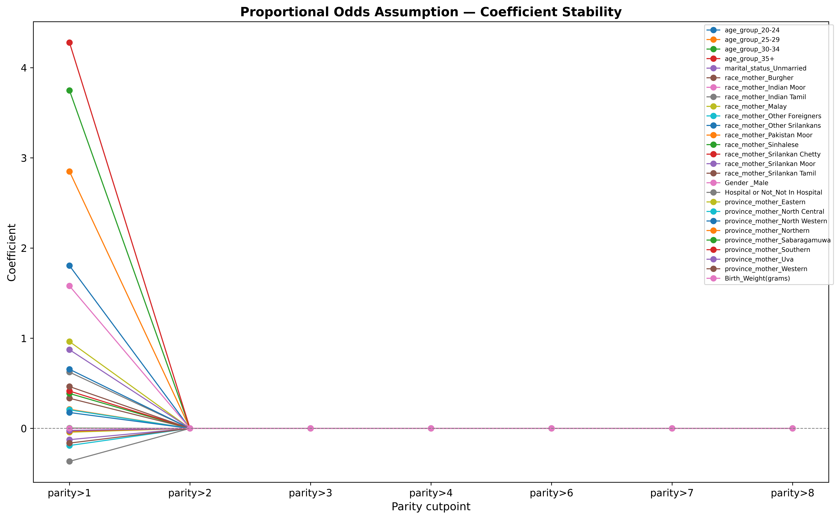
Figure 5.2: Coefficient stability plot for proportional odds assumption test

Quantitative Assessment
• Total variables assessed: 27
• Average coefficient variability (SD): 0.288
• Variables with stable coefficients (SD ≤ 0.5): 22
• Variables with unstable coefficients (SD > 0.5): 5
→ Most unstable variables:
- age_group_35+ (SD = 1.617)
- age_group_30-34 (SD = 1.416)
- age_group_25-29 (SD = 1.077)
- age_group_20-24 (SD = 0.682)
- race_mother_Indian Moor (SD = 0.597)

Interpretation & Recommendations
✓ PROPORTIONAL ODDS ASSUMPTION LIKELY HOLDS
The coefficients show good stability across cutpoints. The ordinal logistic regression model is appropriate.

Saved Files
The following files were saved:
• fig6_proportional_odds.png - Stability plot (300 DPI)
• fig6_proportional_odds_hd.png - High-resolution plot (600 DPI)

